Date: 28/08/2022

NAVTTC Batch-III

DHA SUFFA UNIVERSITY

ADVISOR

Dr. Nauman Qureshi Sir Humza Farrukh

STUDENT

M. AHSAN JAMIL AWAN

CNIC #42301-8153517-9

 

# ANSYS AIRFOIL CFD

ASSIGNMENT # 2 REPORT

**Table of Contents**

## I II III

IV

V

Description of task Geometry Preparation Mesh generation

Brief description of all selected assumptions and models for the simulation in Ansys Fluent

presentation and interpretation of result

Page

3

6

9

10

2 Geometry Preparation

NACCA Airfoil 4412

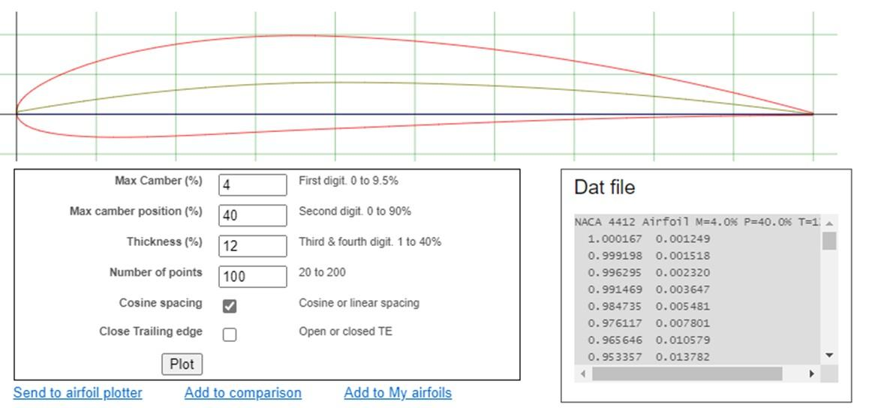

Downloaded data file of NACCA Airfoil 4412 from airfoil tool website

4

Domain prepared in Design Modeler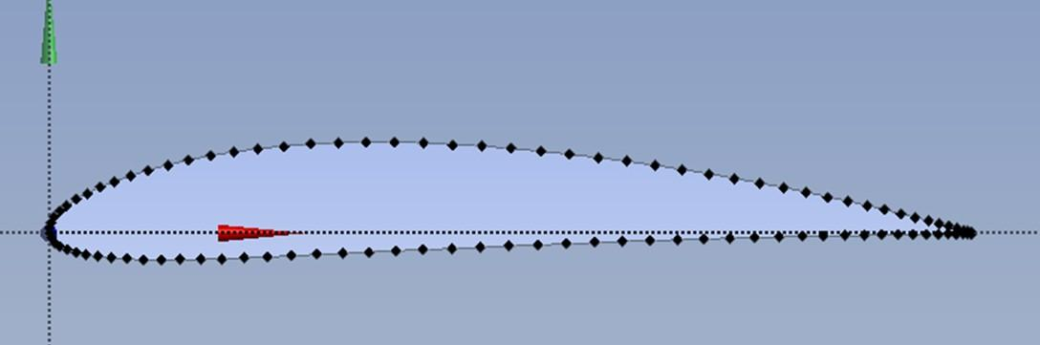

### Dimensions of Domain

Vertical dimensions = 40000mm airfoil is at mid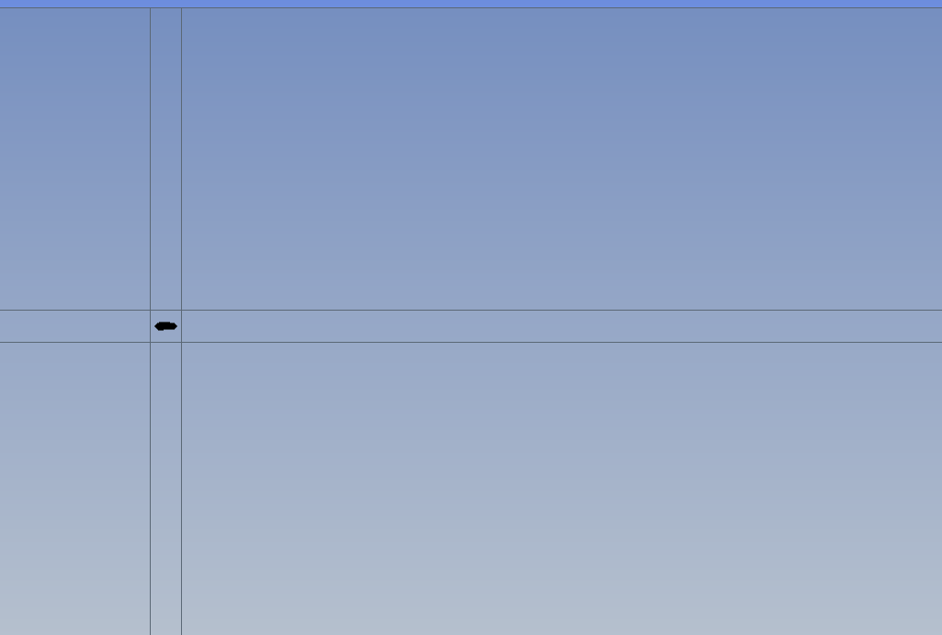

Horizontal dimensions = 60000mm airfoil is 50000mm from right side.

2 Mesh generation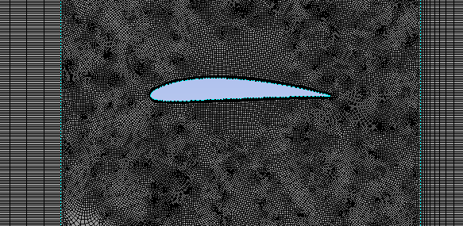

## 6

**Mesh Independence**

Table showing mesh independence: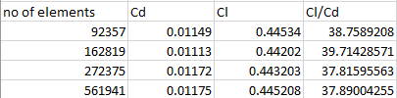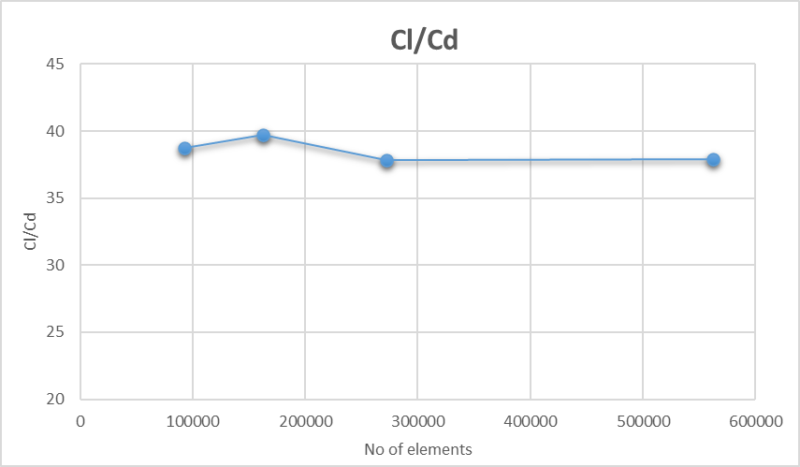

Graph of table: Cl/Cd vs No. of elements

6

Results for 0°angle of attacks.

Velocity contour Pressure contour

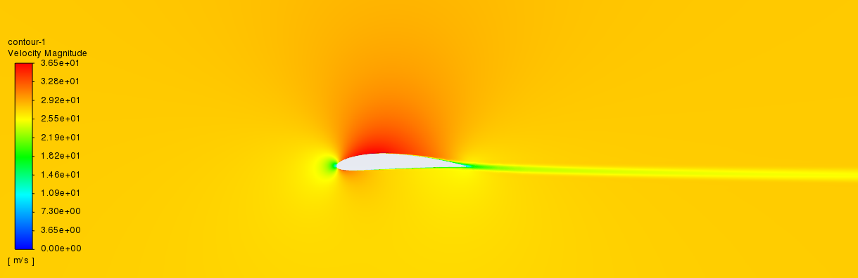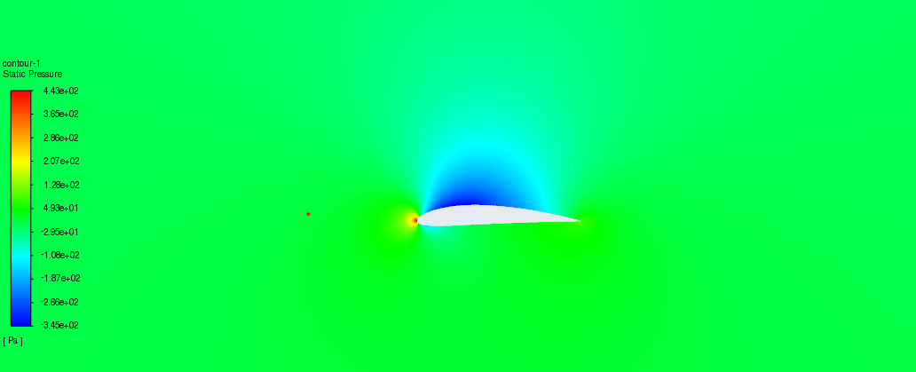

Wall Yplus plot Cl and Cd plot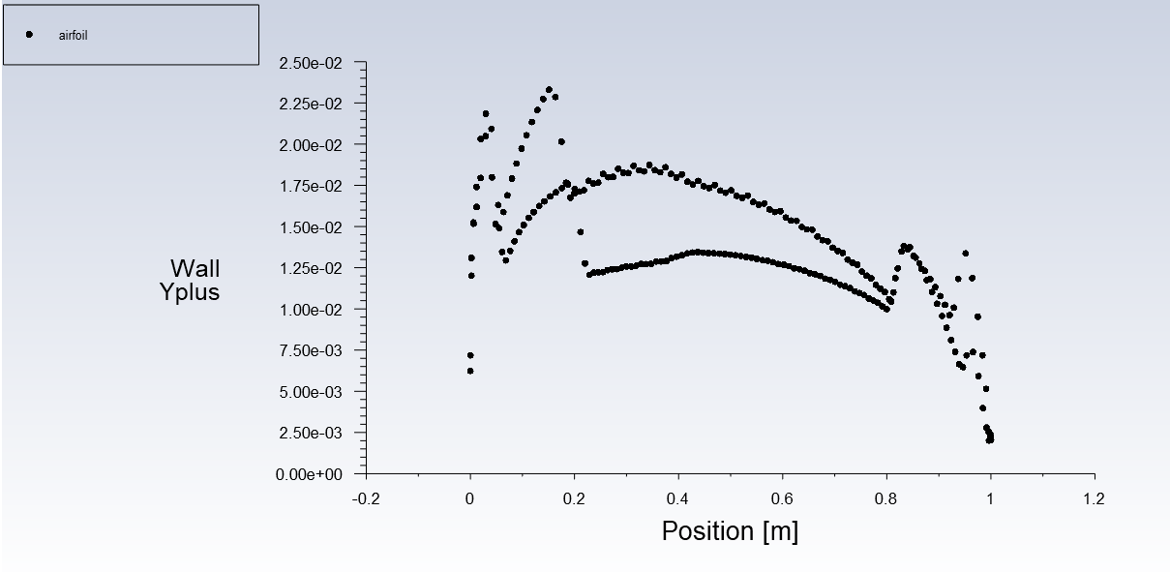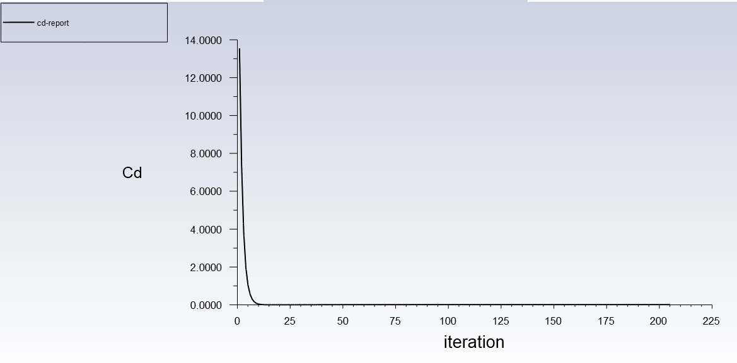

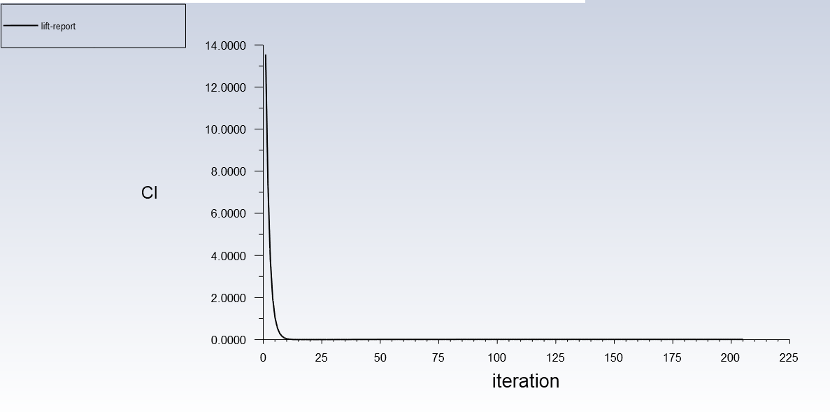

Results for 10°angle of attacks.

Velocity contour Pressure contour

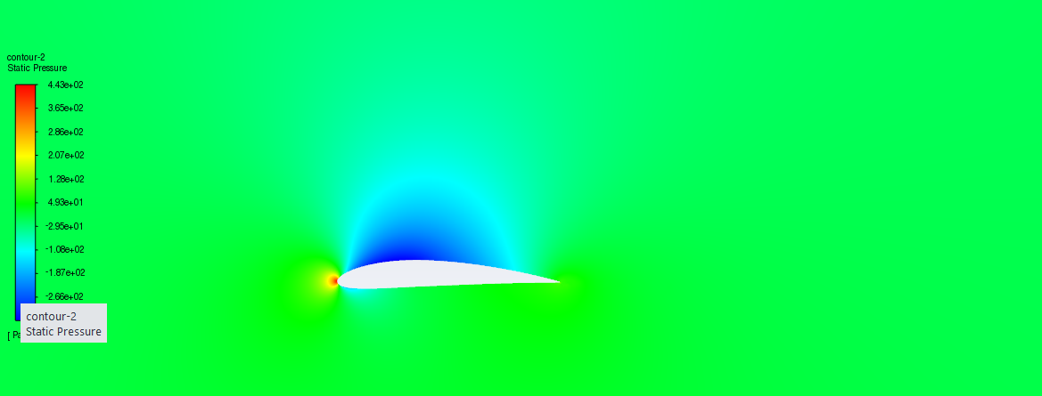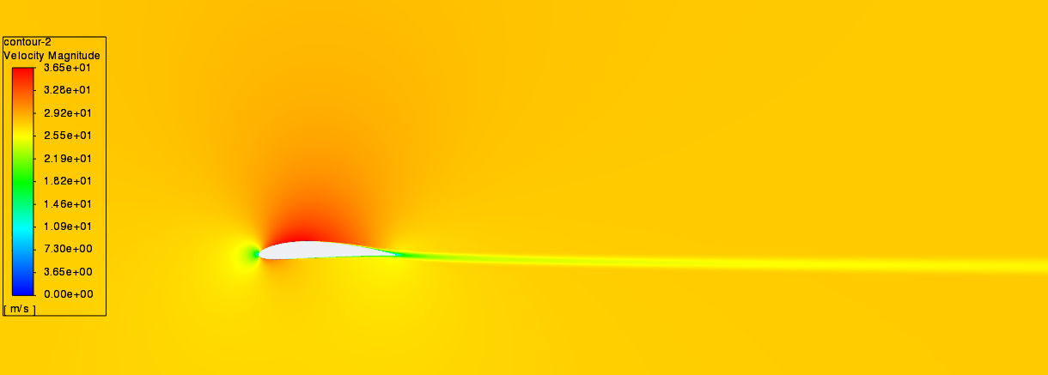

Wall Yplus plot Cl and Cd plot

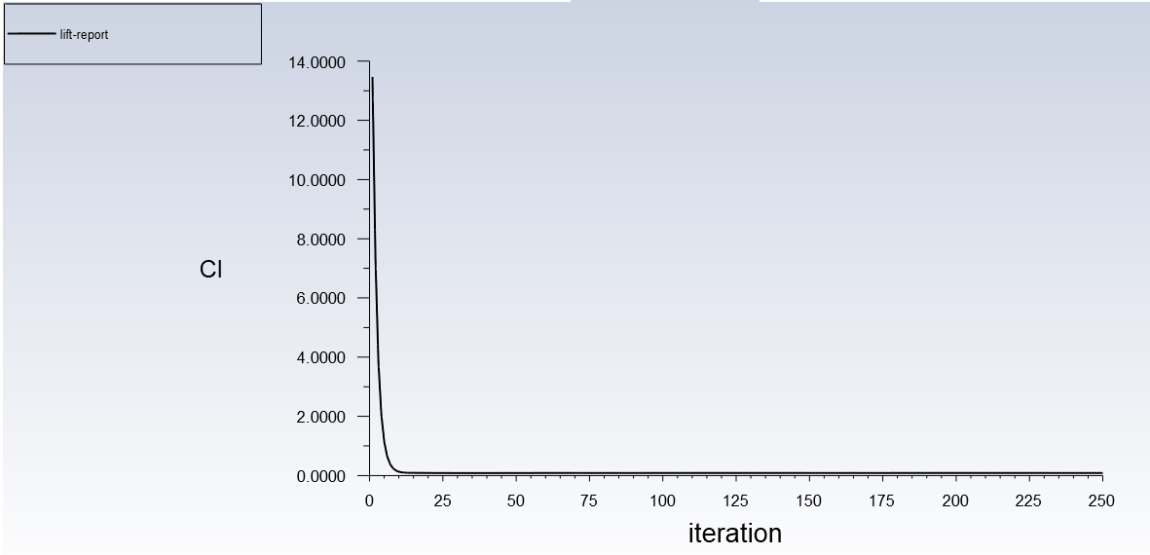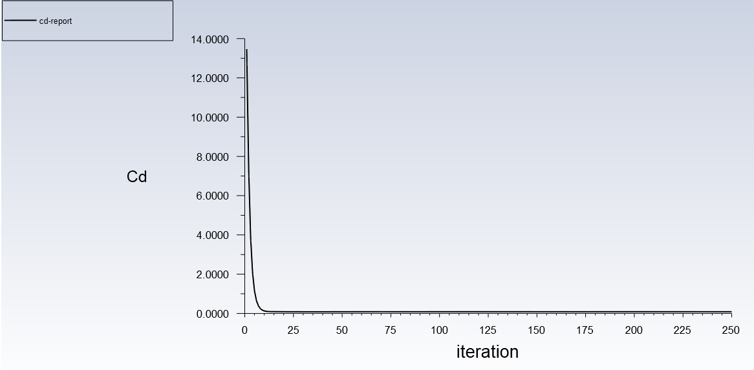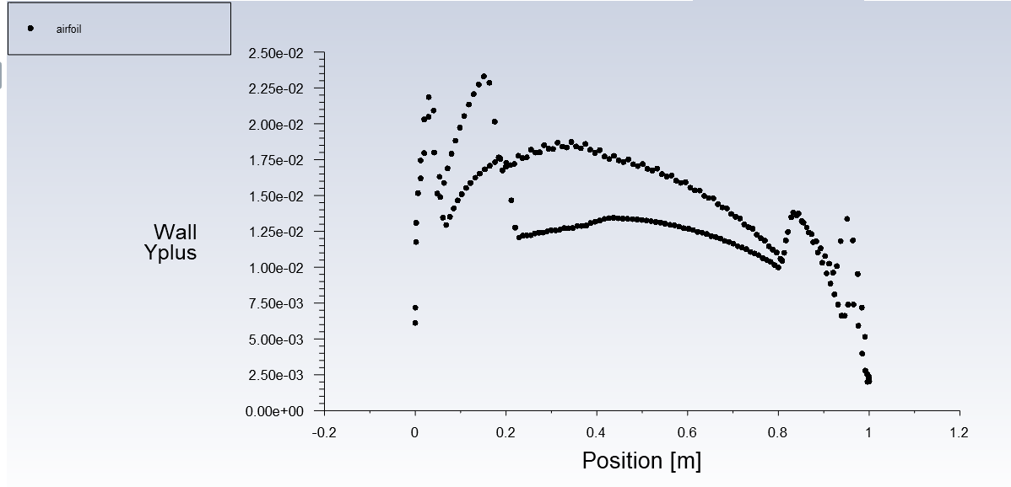

Results for -10°angle of attacks.

Velocity contour Pressure contour

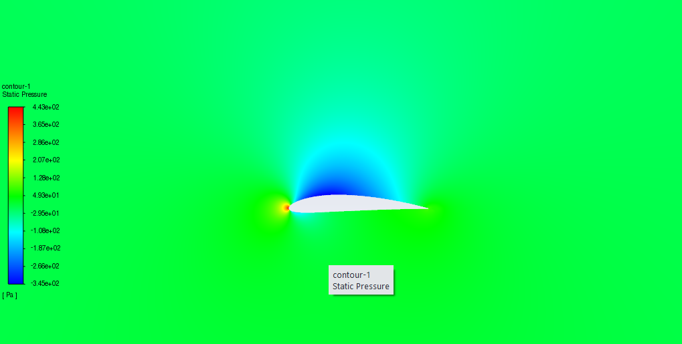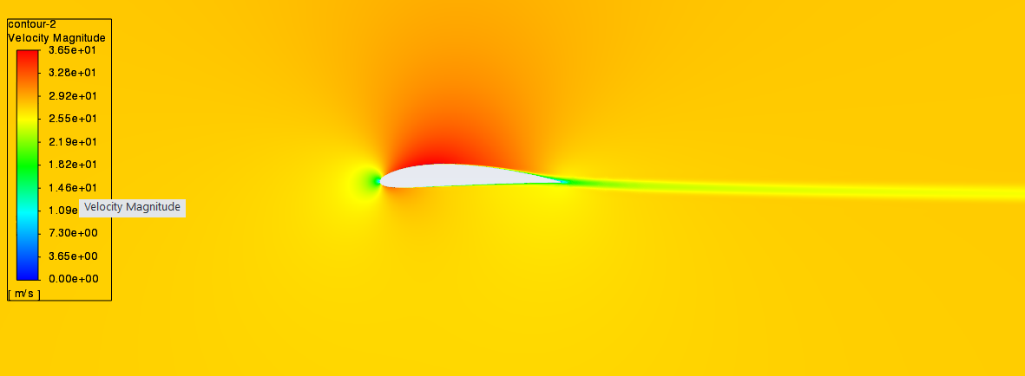

Wall Yplus plot Cl and Cd plot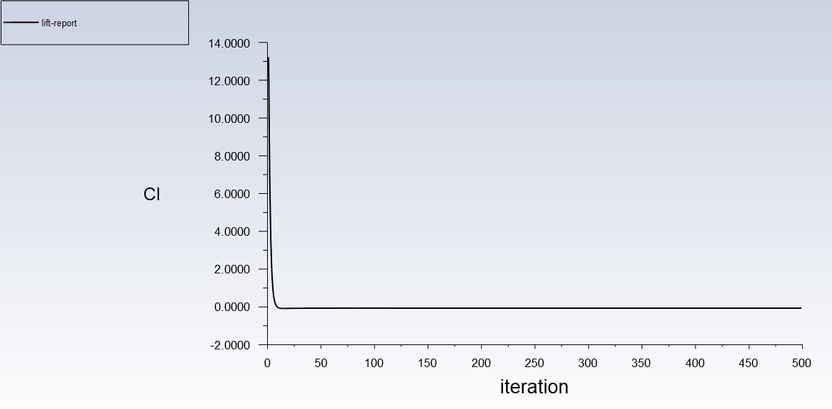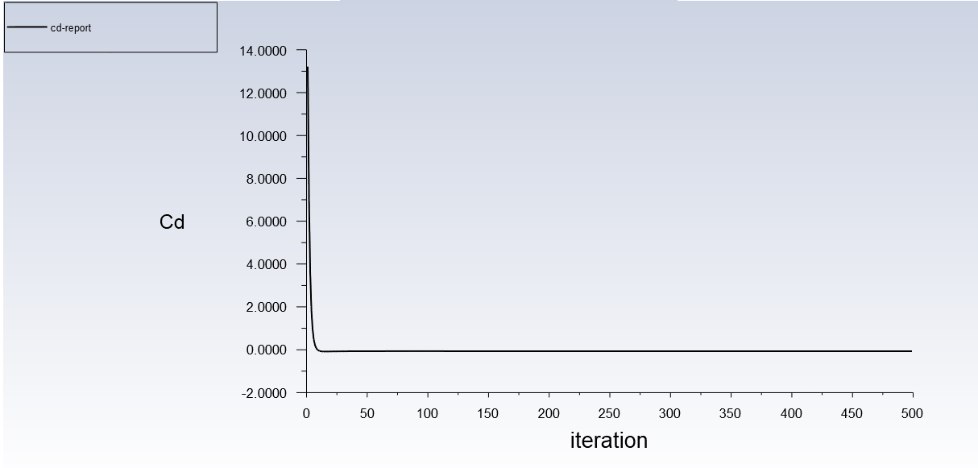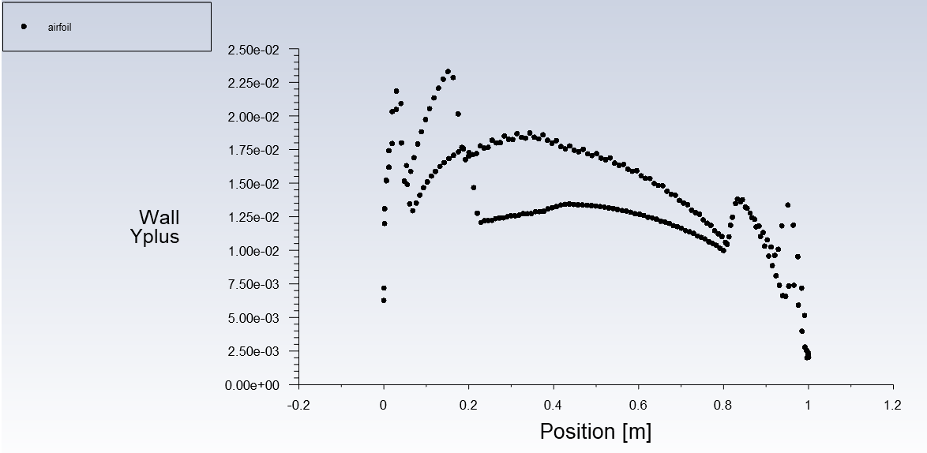

Computed values of Cl, Cd and Cl/Cd in a table Graph of Cl vs Cd

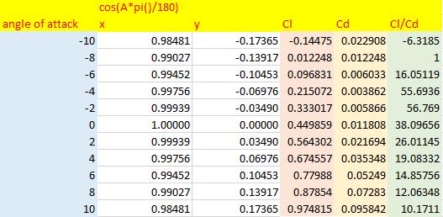

Graph of Cl vs Angle of Attack Graph of Cd vs Angle of Attack

Graph of Cl/Cd vs Angle of Attack